**1. (40=20+20)** 100 stations use a wireless communications channel bandwidth of 1 MHz, in band 400MHz-401MHz.  
(i) Assuming all 100 stations use FDM (Frequency Division Multiplexing), what is the usual bandwidth allocation for each station?

ANSWER: 1/100 = 0.01 MHz, or 10 kH

(ii) Assuming all 100 stations use CDMA (Code Division Multiple Access), what is the usual bandwidth allocation for each station?

ANSWER: 1MHZ BÖLÜNMÜYOR

**2. (40=15+15+10)** DLL Error Control and CRC:

(i) How many bits does any generator polynomial G(x) contain if CRC is 32 bits?

ANSWER: formula is k+n bits = 1+32=33 bits 33

(ii) How many bits should G(x) contain if burst errors up to 64 bits are to be detected?

ANSWER:

* burst errors detect is calculating with (1 – 2^−n). = 1-2^(-64) = 1 bits
* 65

(iii) Write the error polynomial representation E(x) for single bit errors.

* The error polynomial E(x) =xi

**3. (40=20+20)** A-to-B data link layer communications channel has a bit rate of 4Kbps, A-to-B propogation delay 20 msec, B-to-A delay the same, frame size 160 bits and stop-and-wait (that is, 1-bit sliding window, Protocol 4) protocol is used.

**(i)** Assuming simplex data channel, that is no reverse data traffic, immediate individual ack and ignorable ack transmission time, compute the channel utilization. Show your work.

ANSWER: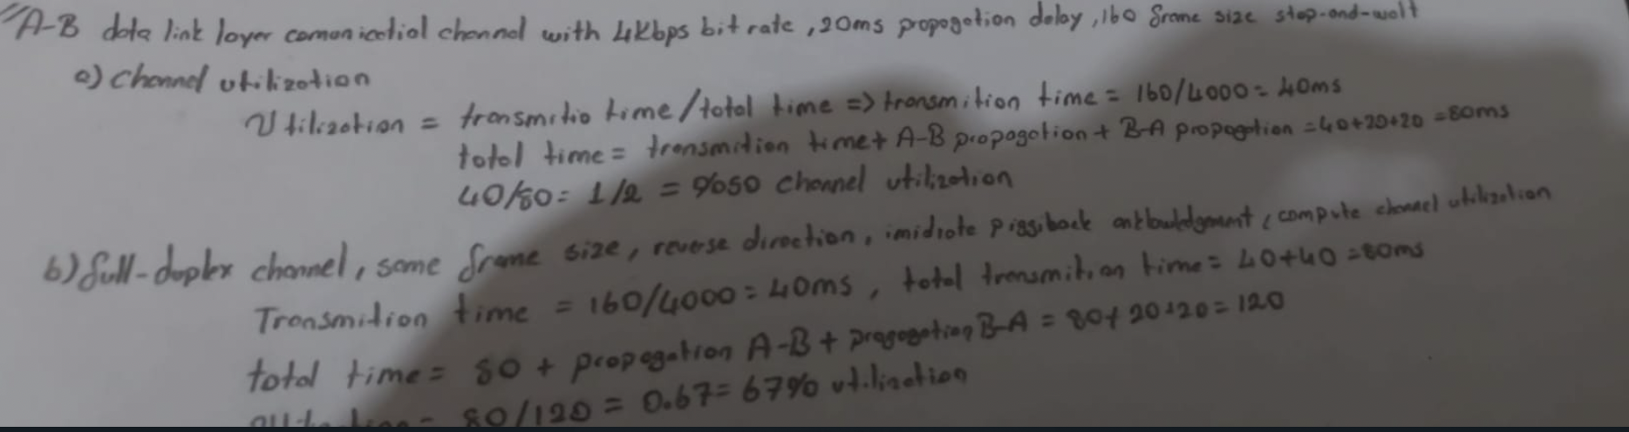

**4. (40=30+10+10)** About 802.3 Ethernet, hubs and switches

(i) Early 10Mbps 802.3 Ethernet is 1-Persistant CSMA/CD (CSMA:Carrier Sense Multiple Access, CD: Collision Detection). Briefly explain how 1-Persistant CSMA/CD functions.

ANSWER:

1-Persistent Carrier Sense Multiple Access with Collision Detection (CSMA/CD) is a protocol used in early 10 Mbps Ethernet networks to manage access to the shared communication medium. It is based on the 1-persistent protocol, which means that a station that is ready to transmit data will always attempt to do so as soon as it detects an idle channel.

The 1-Persistent CSMA/CD protocol operates as follows:

A station that wants to transmit data listens to the channel to determine if it is currently being used by another station.

If the channel is idle, the station begins transmitting its data immediately.

If the channel is busy, the station waits until it becomes idle before transmitting its data.

If two or more stations try to transmit data at the same time, a collision is detected, and all stations involved in the collision stop transmitting and wait for a random amount of time before trying again.

The station continues to transmit its data until it is finished or until a collision is detected.

4 ii

An 802.3 Ethernet hub that supports spanning trees is a network device that allows multiple computers to connect to each other and to share data and resources. The hub operates by forwarding data packets received from one computer to all other computers connected to the hub.

The spanning tree protocol is a networking protocol that allows multiple switches and hubs to be connected together to form a larger network. The goal of the spanning tree protocol is to prevent loops in the network, which can occur when there are multiple paths between two devices.

When an 802.3 Ethernet hub that supports spanning trees is connected to a network, it sends out a broadcast message to all other devices on the network announcing its presence. The other devices on the network respond to this message by sending their own messages announcing their presence.

The hub then uses the information it receives from these messages to build a map of the network, which it uses to determine the best path for sending data packets to other devices. If a loop is detected in the network, the hub uses the spanning tree protocol to block one of the paths, effectively breaking the loop and preventing data packets from being sent in circles.

In summary, an 802.3 Ethernet hub that supports spanning trees operates by forwarding data packets received from one computer to all other computers connected to the hub, and by using the spanning tree protocol to prevent loops in the network.

4 iii

The Media Access Control (MAC) layer is responsible for controlling access to the shared communication medium in a network. In a MAC layer protocol, the sender MAC layer sends a MAC frame to the receiver MAC layer, and the receiver MAC layer acknowledges the receipt of the frame.

There are several ways in which the receiver MAC layer can acknowledge the receipt of a MAC frame. One common method is for the receiver to send an acknowledgement (ACK) frame back to the sender. This ACK frame is typically a small, low-overhead frame that contains a sequence number or other identifier that allows the sender to match it to the original MAC frame.

Another method is for the receiver to send an acknowledgement as part of the next MAC frame it transmits. This is known as piggybacking the acknowledgement on the next frame.

In both cases, the acknowledgement is used to confirm that the original MAC frame was received correctly by the receiver. If the sender does not receive an acknowledgement, it can assume that the MAC frame was not received and can retransmit the frame.

**5. (50)** Make a short list of operation steps,carried out by TCP/IP Network Layer, to route an incoming IPv4 packet.

The TCP/IP Network Layer is responsible for routing packets within a network and forwarding them to their destination. Here is a short list of operation steps that the Network Layer carries out to route an incoming IPv4 packet:

1-Identify the destination address of the packet: The Network Layer first examines the destination address of the packet to determine its ultimate destination.

2-Look up the route to the destination: The Network Layer maintains a routing table that contains information about the available routes to different destinations. It uses this table to determine the best route to the destination specified in the packet.

3-Forward the packet to the next hop: Based on the route determined in the previous step, the Network Layer forwards the packet to the next hop on the route. This may be another device within the network, or it may be a gateway or router that connects the network to another network.

4-Repeat the process at each hop: The process of looking up the route and forwarding the packet is repeated at each hop until the packet reaches its final destination.

5-Deliver the packet to the destination: Once the packet reaches its final destination, the Network Layer delivers it to the appropriate application or host on the destination device.

**6. (40)** About distance vector routing : Router R1 is directly connected to routers R2, R3 and R4 and there is a distant router Rz somehere in the network. Routing metric is number of hops and all routers are using distance vector routing. Explain all cases of how router R1 updates its routing table entry for Rz, perhaps by giving an example.

**Router R1 receives a routing update from one of its neighbors (R2, R3, or R4) that includes a new or updated entry for Rz. For example, if R3 sends a routing update to R1 with an entry for Rz that indicates that Rz can be reached in 3 hops via R3, R1 will update its routing table to reflect this new information.**

**Router R1 receives a data packet destined for Rz. In this case, R1 will update its routing table to reflect the path taken by the data packet. For example, if R1 receives a data packet from R2 that is destined for Rz, and the packet includes a source route that indicates that Rz can be reached in 2 hops via R2, R1 will update its routing table to reflect this information.**

**Router R1 sends a routing update to one of its neighbors (R2, R3, or R4) that includes an entry for Rz. For example, if R1 has an entry in its routing table for Rz that indicates that Rz can be reached in 4 hops via R4, R1 will include this entry in its routing update to R2, R3, and R4.**

**It's worth noting that these are just a few examples of how router R1 might update its routing table entry for Rz in a distance vector routing environment. The specific details of how the routing table is updated can vary depending on the specific implementation of the distance vector algorithm.**

**7. (50=5*10)** IP Adresses, Address Classes, Network and Subnet Numbers. Masks

**(i) The address class of IP address 10.100.200.1 is a Class A address.**

**(ii) The network number of IP address 10.100.200.1 is 10.**

**(iii) The host number of IP address 10.100.200.1 is 100.200.1.**

**(iv) If the mask for IP address 136.137.138.66 is 255.255.255.0, the network number and subnet number of the address is 136.137.138.0.**

**(v) If the mask for IP address 136.137.138.66 is 255.255.255.0, the host number of the address is 0.66.**

**8. (Question for additional points, +40)** Given a router with 8 lines and 12,500 packets/sec packet arrival rate per line, compute the time available to process each packet by the router, including the routing table search time. Show your work.

**If we plug in the values given in the question, the total number of packets the router can process in a second is 8 lines * 12,500 packets/sec/line = 100,000 packets/sec. The time available to process each packet is therefore t/100,000 seconds.**